**SOP For Design of Web Page**

# Step 1: Planning the webpage

* Defined the purpose of the webpage.
* Determined the desired layout and functionality. Determined the content that the webpage include and its organization on the Web Page. Decided features or functionality the webpage will have.

# Step 2: Designing the webpage

* Created wireframes and mock-ups.
* Followed the visual design principles, i.e. Use colour, typography, and imagery to create a visually appealing webpage.

# Step 3: Writing the HTML code

• HTML is the language that defines the structure of a webpage. It is used to create the basic elements of a webpage, such as headings, paragraphs, images, and links.

# • Header

* Main Menu
* 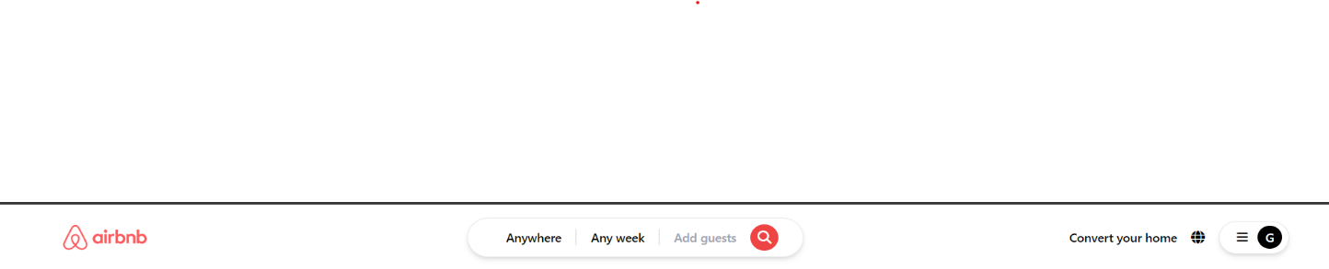Search Option

# • Main Body

* Extra feature in the Site
* 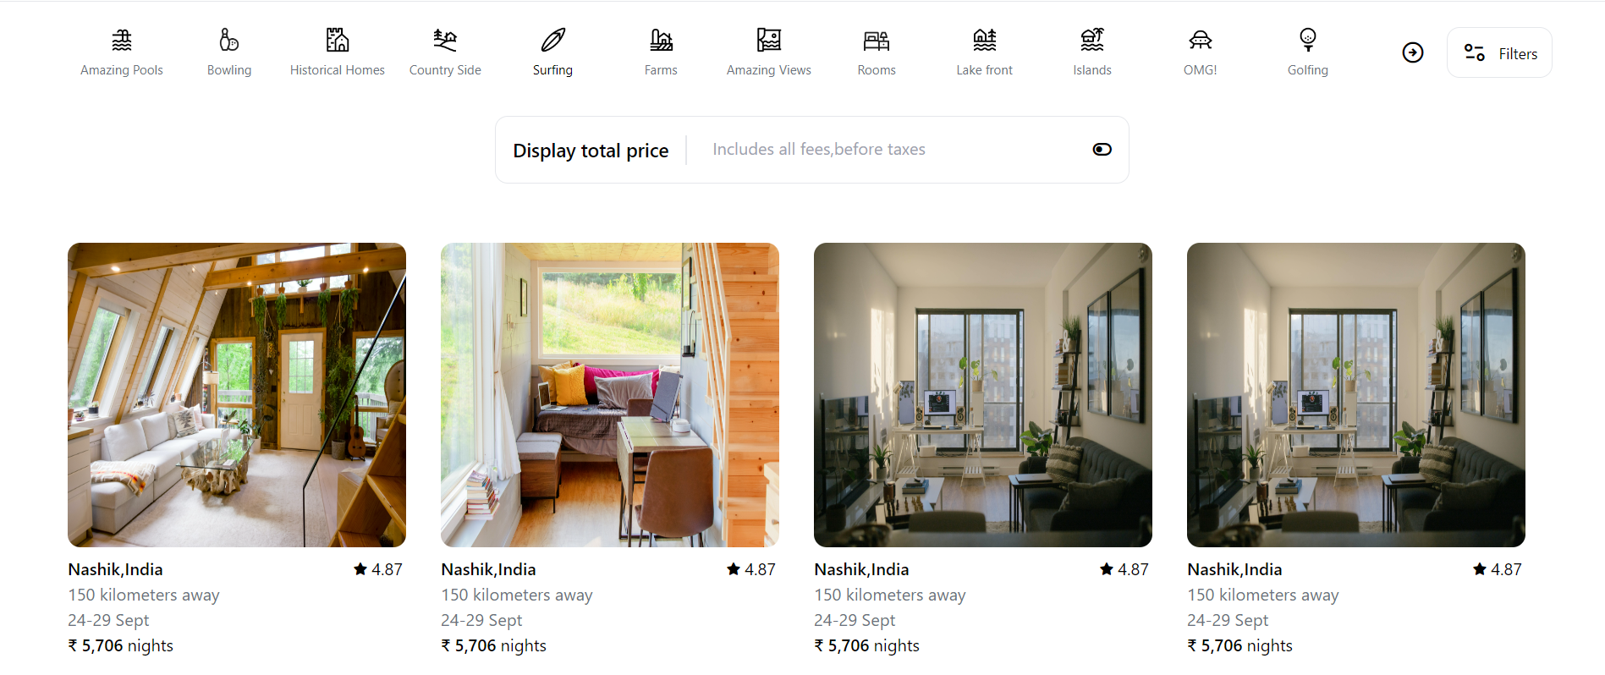Near By Collection

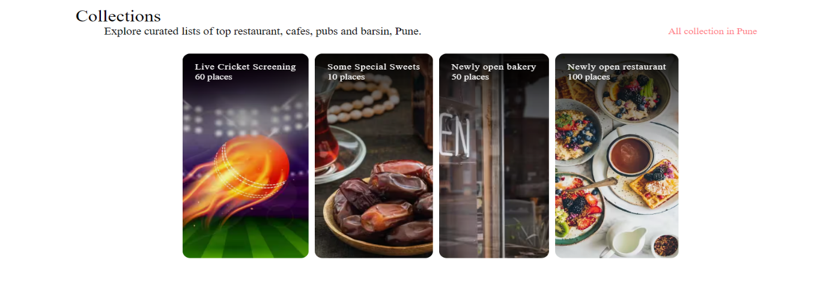

# • Footer

* 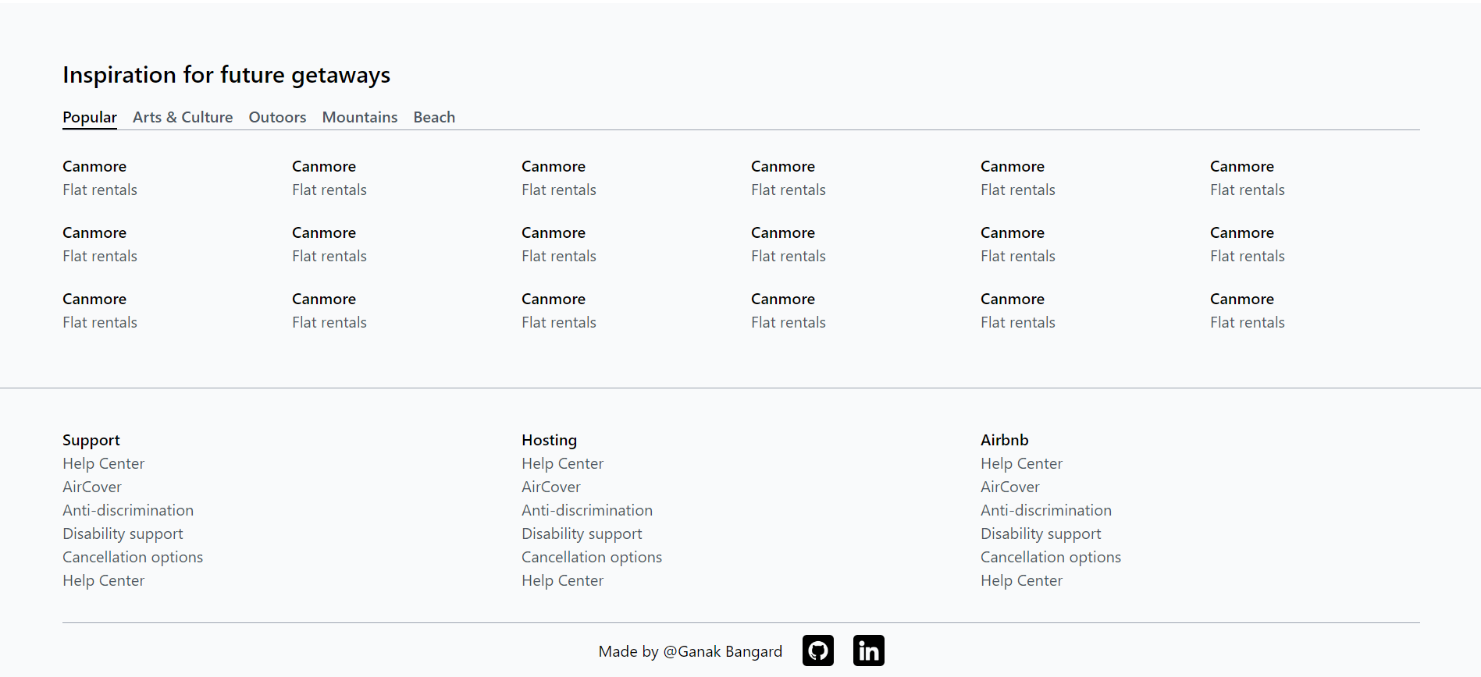Social media links

# Step 4: Writing the CSS code

* CSS is the language that styles the webpage. It is used to control the fonts, colours, layout, and other aspects of the webpage's appearance.
* Start by creating a CSS style sheet. This is a separate file that contains the CSS code for the webpage.
* Select the HTML elements that you want to style. Use CSS selectors to select the HTML elements that you want to style.
* Apply the CSS styles. Once you have selected the HTML elements, you can apply the CSS styles. This includes setting the font family, font size, colour, background-colour, and other properties.

# Step 6: Testing of the webpage

* Tested the webpage on different browsers to make sure that the webpage works correctly on all major browsers and devices.

1. 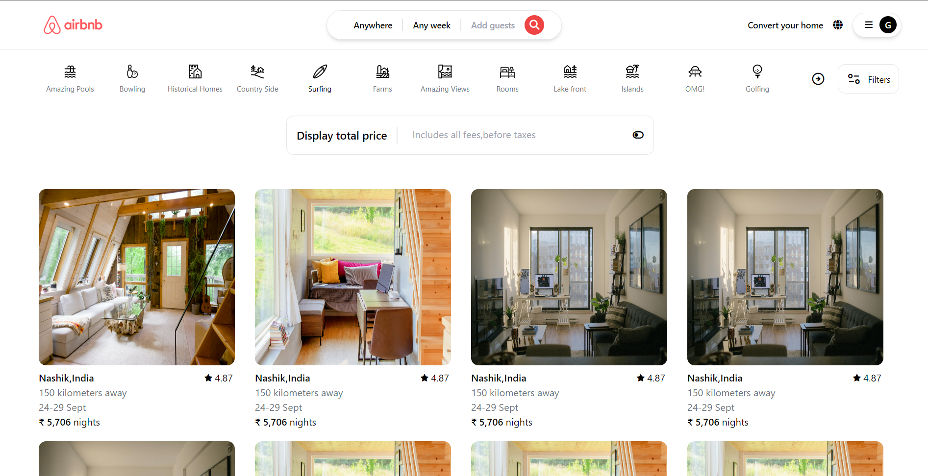Testing it on Laptop